2023-24 GARY FFA INFORMATION
Website: https://garyffa.ffanow.org/default.aspx?ID=55172
**This is a summary of some of the most important information about FFA created by the teachers, but does NOT take the place of the information given out in classes or doing the research to become informed about all events offered.
Gary FFA Remind Group FOR ALL STUDENTS AND ALL PARENTS:
Text to this number: 81010
This message: @ffeec6h

Advisors: Paul Harvey (pharvey@garyisd.net)
Jessica Shadix (jshadix@garyisd.net)
What does this mean? We believe ALL students will find something to be involved in through our classes!

FFA DUES: students are asked to pay their local FFA dues by Oct 1 each school year. Students will not be allowed to travel, compete or be eligible for awards, degrees or scholarships if they aren’t dues-paid members of the Gary FFA.
**DUES ARE $25 (until 9/1) and $30 (9/2-10/1), students will receive an FFA TShirt (we will wear these to many events) and a Harvey-burger lunch at school!
**If a student does not join by the deadline they will be unable to participate in the activities offered through Gary FFA.
FFA Officers:
President- Caitlynn Ayers
Vice President- Lane Cartwright
Secretary- Della Kiper
Treasurer- Emorie Comer
Reporter- Braley Weems
Sentinel-
Student Advisor-

Chapter officers serve a vital function in FFA. By taking a major leadership role, these students grow from the experience and benefit the chapter. It should be the officers' goal to lead by example and encourage other members to participate in chapter activities. To be an FFA Officer a student must go through the election process in April and meet all qualifications.
Important Dates:
- A beginning of the year “parent meeting” will be set each year to discuss possibilities for students in all classes and through Gary FFA. This is a great time to come and ask questions, find out how the program can help students and to set goals for students!
- FFA Meetings will be held during “CAT” time and are required for members
- Dates will be posted in the Advisor’s classrooms for upcoming events, please also check google classroom and join any necessary Remind groups

Gary FFA
Is for all students in ALL Agricultural Education Classes: Principles of Agriculture, Floral Design, Forestry, Wildlife and Agricultural Mechanics (Welding). FFA prepares students for life, no matter what career path a student plans to pursue. FFA is for students in athletics, theater, etc. We strive to work around all schedules, and it is helpful that the lessons learned in our classes are directly related to the contests and events our students participate in. FFA helps create WELL-ROUNDED students!
Through FFA we teach students how to be prepared adults. We teach them skills that can be used for future careers or simply in life. There is no push for students to be “farmers” or “ranchers”, we simply teach lessons through Agricultural Education (who doesn’t need to or want to know how to be a better consumer? Or where their food comes from?).

There are three “parts” to Agricultural Education-
1. Classroom/Laboratory- the skills learned in ag classes can help students in contests and LIFE!
2. SAE (Supervised Agricultural Experiences)- students are required to have some sort of “project” or “job” and keep records on it in order to qualify for degrees, awards and scholarships.
3. FFA (all students in all Ag Classes are members of Gary FFA and are able to participate if they chose)- in order to best understand what they learn and to qualify for awards, degrees and scholarships, students need to be active in all FFA events (meetings, contests, conferences, conventions, etc).
**Simply being in an Ag Class won’t result in the many opportunities we offer, students must participate in the activities we offer to be eligible for awards, degrees and scholarships.
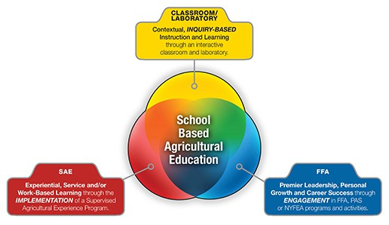
GARY FFA MEMBERSHIP
- All members are required to pay their local $25 dues prior to Sept. 1 and $30 between 9/2-10/1 each school year to receive their FFA TShirt and attend the member lunch. This membership fee is for local use and students will receive an FFA T-shirt (which will be needed on numerous occasions).
- An FFA MEMBER is any student enrolled in an Ag Class at Gary ISD that pays their dues by Oct. 1st.
- A JR FFA MEMBER IS A SIBLING OF A CURRENT DUES PAID FFA MEMBER and student enrolled in Gary ISD who wants to show livestock through Gary FFA (other activities are limited to only true FFA Members and won’t be available to students until they are enrolled in an Ag Class). All Jr. FFA Members are required to pay their local $25/$30 dues prior to Oct 1 each school year to receive their FFA TShirt. Jr. Members are asked to participate in meetings, fundraisers and events just like FFA Members.
**We encourage all FFA and Jr. FFA Members to also join Gary 4-H for a variety of great opportunities as well! Students CAN AND SHOULD DO BOTH if they are able!
Great Resources to learn more about FFA and its benefits for students.
https://www.ffa.org/about/
https://www.ffa.org/ffa-history/
https://www.ffa.org/ffa-history/history-of-the-ffa-jacket/
https://pcjls.net/

THINGS TO KNOW
- Some Agricultural classes can serve as core class credits (Floral Design is an ART Credit).
- All students should follow the “pathway” they chose throughout high school
- Ag Pathways offer certifications that can help students gain employment and will help on scholarship applications
- We suggest that students take the TSI, ACT and SAT as a Sophomore for the first time and then depending on their score, take it at least twice their junior year. By the 3rd time of taking it, they should reach their best score (minimum scores are required for some colleges and scholarships).
- ALL EVENTS THAT STUDENTS PARTICIPATE IN REQUIRE STUDENTS TO MAINTAIN PASSING GRADES BASED ON UIL RULES
THE FFA JACKET
“FFA Official Dress” (or the FFA uniform) is iconic attire that can be recognized by MANY! The jacket is a tradition that began years ago and is still the symbol of leadership and growth. While not “all” FFA events call for the use of an FFA Jacket, if students plan to attend many events, they will need to order a jacket when they begin their FFA Career (one jacket for their entire high school career is usually plenty, as long as fit isn’t an issue.) “Official Dress” may be seen as “old school” or “not cool” to some, but a sea of blue and gold jackets at any event is a very prestigious and respected thing! Students won’t be asked to wear their jackets or official dress outside of FFA Events.
We will assist students in ordering their jackets and give them a list of the proper official dress that is required at some events.
**If a student isn’t able to purchase/afford an FFA Jacket- there is an ANONYMOUS program where they could be awarded a jacket! Students/Parents need to visit this website and go through the steps for the jacket. https://www.ffa.org/giveblue/
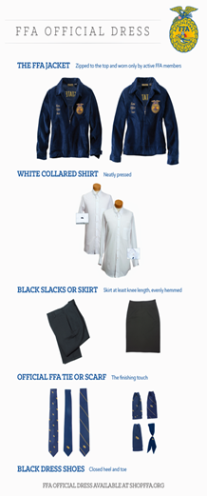

(SAE) SUPERVISED AGRICULTURAL EXPERIENCES
file:///C:/Users/jessi/Downloads/NCAE_SAEforAll_Student_Guide.pdf
The Supervised Agricultural Experience (SAE) program involves practical agricultural activities performed by students outside of scheduled classroom and laboratory time. SAEs provide a method in agricultural education for students to receive real-world career experiences in an area of agriculture that they are most interested in. Supervised Agricultural Experiences are an important component of agricultural education and are a required element of all Agriculture, Food and Natural Resources (AFNR) courses.
The purpose of a Supervised Agricultural Experience is to teach students true life skills like leadership, speaking ability, responsibility, self-motivation, record keeping and more!
This link is an AMAZING detailed document of “SAEs”- most people think of SAE’s as animal projects that are shown at livestock shows, but the options vary (check out the website for more info!)! ANIMALS ARE NOT REQUIRED! Some other options for SAE’s are: ag mechanics projects, placement (jobs in the Agricultural Industry), volunteer work (like volunteering at the local Potbelly Pig Rescue here in Gary, TX!), and more!
Take a look at the document link, most students are already doing something to “count” or could do something easily!
WHY SAE?
· Students can qualify for awards and scholarships when they keep records on these projects, jobs, etc.
· MONEY! Students can make money while IN SCHOOL by working or raising animals!
· SAEs are things that can happen at the local, state and national levels (there are livestock shows all over Texas and beyond- by participating in state shows, students become eligible for that show’s scholarships!)
SAE Livestock LEVELS?
- Local Panola County Livestock Show (Ag Mechanics is an option here!)
- State or “Major” Livestock Shows (Ag Mechanics is an option!)
- National Livestock Shows
LEADERSHIP DEVELOPMENT EVENTS:
https://texasffa.org/lde
These events happen in the fall semester and spots are limited- so students will need to express interest when teams are being made (Examples: Radio Broadcasting, Agricultural Advocacy and Skills Demonstration). There are practice times required for these contests and students will miss school to compete.
Leadership Development Events focus on creating situations for members to demonstrate their abilities in public speaking, decision making, communication and their knowledge of agriculture and the FFA organization. Team and individual events are used to reinforce what is taught in agricultural science classrooms. These are events where we create a script, put together props and present a presentation to judges. There are “practice or invitational” contests to help prepare for the real contests (much like a sport scrimmage). Students compete at the district level in hopes of advancing to area and state.
CAREER DEVELOPMENT EVENTS
https://texasffa.org/cde
These events happen in the fall and spring semesters (Examples: Forestry, Wildlife and Floriculture). There are practice times required for these contests and students will miss school to compete.
Career Development Events build on what is learned in agricultural classes and encourage members to put their knowledge into practice. These events are designed to help a member prepare for a career in agriculture by testing and challenging the student's technical, leadership, interpersonal and teamwork skills as well as their knowledge of the subject matter. CDEs answer the question, "When will I use this knowledge in the real world?"
SPEAKING EVENTS
https://texasffa.org/speaking-events
Speaking Development Events are designed to develop the ability of all FFA members to express themselves on a given subject. Students are encouraged to develop their communication skills and learn to formulate their remarks for presentation in a variety of situations. The state finals of the speaking development events are held in conjunction with the Texas FFA Convention in July.
These events are offered at the local, district, area and state levels. Students can also do speaking events at Major Livestock Shows- most of the time a student can use the SAME speech at different competitions and for many years! It is WORTH IT to read the rules at these competitions and compete!

FFA RODEO
https://texasffarodeo.ffanow.org/default.aspx?ID=680
The FFA Rodeo is open to all FFA Members and is held in conjunction with the State Convention each year (July). There are no qualifying events for this rodeo, students must enter by the deadline (see rules for more details). Travel and hauling animals is the responsibility of the student, but Gary FFA will assist with paperwork and other support.
**The FFA Rodeo is separate from the “high school rodeo” and an additional opportunity for students to exhibit their talents.
COMMUNITY SERVICE
https://texasffa.org/community-service
FFA Members should achieve 25 community service hours by March of their Junior Year (or 3rd year of Ag, this could be a students’ Sophomore year). 40 hours by their senior year is suggested for scholarship purposes. These hours need to vary between groups and purposes and not all with the same organization.

STATE CONVENTION
https://www.texasffa.org/state-convention
The Texas State FFA Convention is held during the 2nd week of July and a culmination of the year’s events and successes. Students attend convention to receive awards, scholarships and degrees. Students participate in a variety of leadership activities and are part of the largest student led program held in the state. Students are required to have official dress for this event.
This event is an AMAZING experience!
RECORD KEEPING
www.theaet.com
For all of these “things” that students do and participate in to mean something or “count”, they need to be entered into the FFA record keeping system: www.theaet.com. It is VITAL that students keep up with these records as the year progresses (there is an APP!), full and complete sentences, punctuation and extensive descriptions are VERY important (think flower-y). When students want to apply for degrees, awards or scholarships, they should be up-to-date with their records and be able to “press print” for their information.
Pictures of ALL activities are important- students should take 2-3 pictures of EVERY activity that they do. These pictures need to be “action” pictures and need to have the student’s face in them (proper attire, PPE, etc. are required).
SCHOLARSHIPS
Being a member of the FFA is VERY prestigious on ANY scholarship a student may apply for. Being WELL-ROUNDED is VERY important for all scholarships- no matter what career a student wants to pursue! Being an ACTIVE FFA member is the ONLY way to get BIG FFA Scholarships- to “be active” students need to have SAEs, be on LDE and CDE teams and do things ABOVE the local level (attend camps, attend conferences, attend conventions, do well on teams and advance to the next levels, be officers above the local level, etc). It is imperative that PARENTS and STUDENTS use this list as a “check list” each year and that none of the items are skipped or when applying for scholarships, someone will have more boxes checked.
LINKS FOR INFORMATION ON HUGE FFA SCHOLARSHIPS:
https://texasffa.org/docs/Texas%20FFA%20Scholarship_FFA%20Activities%20Rubric_19724.pdf
https://texasffa.org/docs/Texas%20FFA%20Scholarship%20Eligibility,%20FAQs%20and%20Majors_Revised%202019_70184.pdf
https://texasffa.org/docs/Texas%20FFA%20Scholarship%20Evlauation%20Sheet_55743.pdf
**Not taking advantage of the opportunities given over the time a student is in FFA will result in students not qualifying for FFA scholarships. YES! Having “FFA Member” to list on scholarship applications is respectable, but true FFA scholarships require PARTICIPATION in all parts of FFA.
**Students will be informed about opportunities IN CLASS. They will have time AT SCHOOL to study, practice and prepare. It is the students responsibility to share their opportunities with their parents. It is their CHOICE to participate, or not.
**The Remind APP will be used to communicate with parents and students.
LONESTAR DEGREE/SCHOLARSHIPS
https://www.texasffa.org/degrees-of-membership#:~:text=Those%20wishing%20to%20receive%20their,money%20in%20their%20SAE%2C%20demonstrate
Your Lonestar Degree is awarded after your third year in FFA. The criteria is VERY important because it leads to scholarships and other awards. If a student isn’t participating in these things on the list, they will not qualify for their lonestar degree OR HUGE FFA Scholarships!
https://www.texasffa.org/docs/Texas%20FFA%20Scholarship_FFA%20Activities%20Rubric_19724.pdf
Click on the above website and be familiar with expectations of scholarships.
COMMUNICATION
- It is VERY important that students and parents follow the “Gary Junior High & High School” Facebook Page (follow it, set it so you get the notifications, etc).
- We will utilize the “REMIND” App for many groups of students and parents. Please download that App and set your phone to receive notifications for it.

** ”I didn’t know” won’t be because the Advisors fail to communicate information. It is VERY important that students learn to gather information and keep up with what is expected (the use of calendars, the use of scheduling and fixing conflicts before the last minute are all valuable skills we hope to instill in our students.)

LETTERMAN JACKETS
We feel that it is important to reward students for their hard work through Gary FFA. Much like athletics, our students can qualify or advance in areas of high caliber and Gary FFA offers qualifications to earn a letterman jacket. Students are responsible for letting their teacher know when they have qualified for a jacket so that a fitting can be scheduled.
Gary ISD will provide the Letterman Jacket, the student/family will be responsible for all patches and extras associated with the cost of the jacket.
QUALIFICATIONS:**While attending Gary ISD.
CHECK LIST #1:
**Only one of the top three boxes required (all other boxes must be checked)

- **A student must compete on a STATE qualifying Leadership Development Event (LDE) OR STATE qualifying Career Development Event (CDE)
AND must participate on an LDE or CDE team (only state level in one, but participation in both is required) in the same school year
- **Win Grand Champion OR Reserve Champion species at the Panola County Livestock Show
- **Make the Sale at any Major Livestock Show (jackpots do not count) with a market animal or win Grand or Reserve Division or above with a breeding animal at any Major Livestock Show
- Run for FFA Office (go through the entire process)
- Student must have participated in all fundraising events (to the minimum number set)
- Have a successful SAE and updated Record Book each semester of qualifying year
- Obtain their Gary FFA Chapter Degree
- Hold a 2.5 GPA or higher
- Have no discipline issues above 3 days ISS for the year

CHECK LIST #2:
**Gary FFA Members in their Junior Year of High School must have completed the following:

- Been a Gary FFA Officer for at least 1 year and followed the officers guidelines
- Competed on an LDE AND CDE team for at least 2 years
- Received their Gary FFA Chapter Degree
- Qualify for their Lonestar Degree (updated records are required)
- Had a successful SAE for at least 2 years through Gary FFA
- Participated in all fundraising events (to the minimum number set) held by Gary FFA

The FFA Advisors reserve the right to award a Letterman Jacket to a student based on merit, participation, and activeness with the chapter. This will only be awarded on a special case basis and all Advisors must vote on and agree on the award.
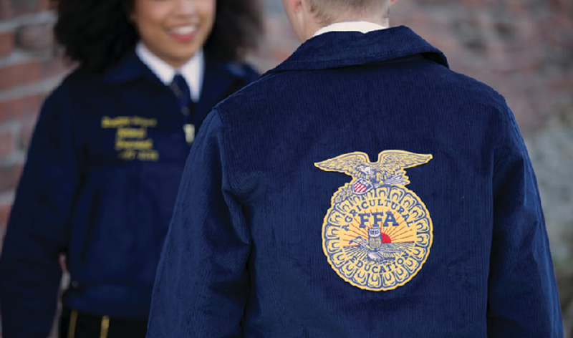
Ordering FFA Jackets
Teachers will help measure students in class, but ordering is the responsibility of the student/parents.
PLACES YOU WILL WEAR OFFICIAL DRESS:
· FFA MEETINGS
· DISTRICT MEETINGS/CONVENTIONS
· AREA MEETINGS/CONVENTIONS
· STATE CONVENTION
· LEADERSHIP DEVELOPMENT EVENT COMPETITIONS
· SPEAKING CONTESTS
· SCHOOL BOARD MEETINGS
· SCHOLARSHIP BANQUETS
· AND MUCH MUCH MORE!!!!

Steps to Order:
- Go to: www.ffa.org
- Click “SHOP: (on the top menu bar towards the right)
- Click “OFFICIAL JACKET”
- Click on either “mens” or “womens”
- You will need to order a jacket AND either a tie (for boys) or scarf (for girls)
- Click on “jackets”
  - If you are a standard size (most jackets) the price will be $60 for the jacket
  - If you are a tailored size (you will need a special measurement for this) the price will be $85 for the jacket
- **We will have jackets available for students to try on to get the perfect fit- please make sure to plan for growth!
- Click “Select Options”
- Click “Select Size”
- Click here to Personalize
- Chapter Number (CHANGE): TX0305 (the name of the chapter should come up to be GARY)
- Advisory Name: Jessica Shadix
- Front Line (Member Name: your name as you would like it):
- SKIP ALL OTHER LINES (we do not suggest adding an office or year because these change)
- CLICK ADD TO CART
- **You DO NOT need an “invite code”- check out as a guest and it will allow you to order easily!

If you have any trouble or questions about this process, please don’t hesitate to let us know! Some students will need their jackets by the middle of October and it sometimes takes 6 weeks to get the jackets back. SO PLEASE ORDER AT YOUR EARLIEST CONVENIENCE.

Thanks!
Gary FFA Advisors

Other Parts of Official Dress that are needed and can be purchased from Wal-Mart or any department store:
Girls:
SOLID White, collared, button up shirt- MUST have button at the neck
SOLID Black skirt (knee length)- pencil skirts work best. No slits or ruffles please.
Black panty hose (several pairs- no “runs” or holes are allowed)- shear black tights can also be worn (not leggings).
SOLID Black- closed toed, close heeled shoes, heels (that can be worn for hours at a time) or flats work best. No buckles, bows, or colored tags are allowed on the shoes.

Boys:
SOLID White, collared, button up shirt- MUST have button at the neck
SOLID Black slacks
Black belt
Black Socks
Black Shoes- black boots are acceptable with leather soles.

While wearing official dress:
- All students are required to be on their best behavior, as they will be representing Gary FFA.
- Jackets can NOT be worn without ALL parts of official dress (ex: you are not allowed to wear your jacket with jeans or at any event that is NOT an FFA event).
- Jackets must be zipped up all the way at all times unless eating, then the jacket can be hung on the back of a chair.
- No hats will be allowed to be worn with Official Dress
- All students are asked to be positive and promote the Gary FFA to the best of their ability. Wearing official dress is a privilege and an honor.
IF YOU ARE IN NEED OF AN FFA JACKET AND CAN NOT AFFORD ONE, PLEASE VISIT: https://www.ffa.org/giveblue/
This program is 100% anonymous.

FFA SENIOR GRADUATION CORDS

To obtain senior FFA Graduation cords (blue and gold), students are required to do the following:
- Attend at least 3 FFA meetings (not including the FFA Banquet) during their senior year (a sign in is required)
- Participate in at least TWO FFA Fundraisers (to the minimum number of items set by advisors) their senior year
- Attend the FFA Banquet of their senior year

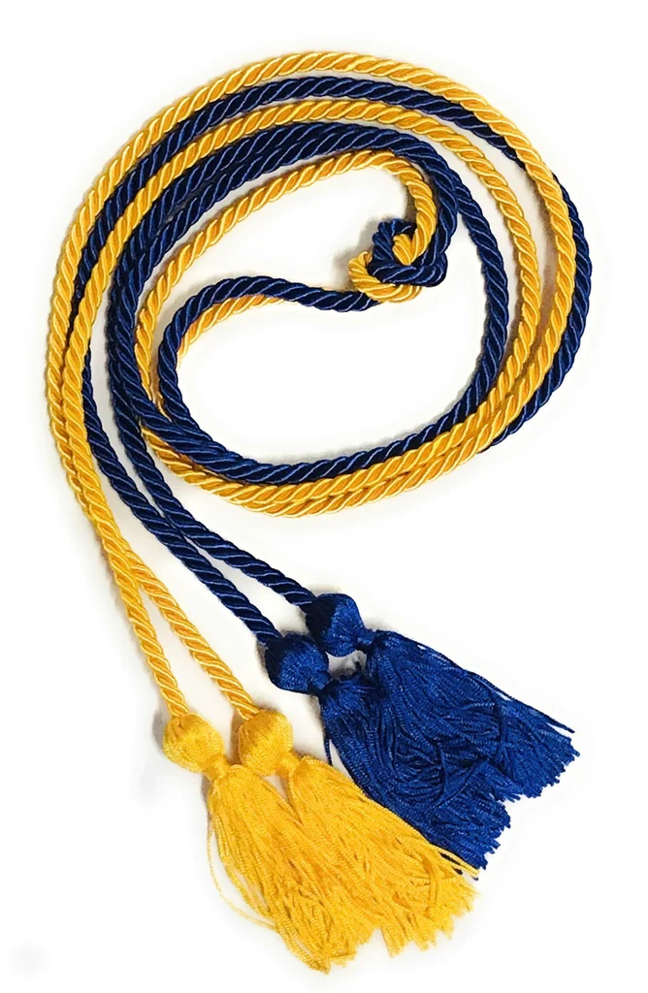

ANIMAL PROJECT COST ESTIMATES
(these are only estimates and averages based on the Advisor’s experiences)- there are scenarios that will be drastically different, please make sure you talk with advisors about all options. These are based on “county” animals and not “major” animals. These numbers are also based on “competitive” animals for our area and breeder connections.
SHOW OPTIONS for ALL animal projects: Panola County, Major Livestock Shows, Jackpot Shows, National Shows and more!
HOW DO YOU “GET” YOUR ANIMALS? YOU HAVE OPTIONS:
● You can purchase your own animals from a “show animal” breeder.
● The Advisors can find animals at a sale or from a breeder.
● Here’s how it works: You figure out your “budget” and get that money together prior to purchasing the animal- some require deposits, some require all money upfront. Some feed is very expensive, some is cheaper. Make sure you understand the FULL investment prior to committing to a project and its possible expenses!
The Average Pig Showman
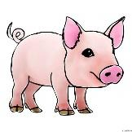
- Cost of Animal: $600
- Feed Cost/week: $30
- Weeks on feed: 18
- Supplies/year: $250
- Extras- Entry fees, vet bills, etc: $200
  - Total Investment Cost/year: $1,590
Hours Spent on Project: 126
Experience….. PRICELESS!

**The student is responsible for all costs and fees associated with any project. The Advisors are only there to help when help is needed. The student keeps all winnings and profit generated by the animal project!

Options: Barrows ONLY at most shows (4-5 MONTH PROJECT)- need to be born around the mid of Aug-first part of Sept for most shows (each show will be slightly different). Pigs need to be roughly 6.5-7 months old at show time.

When do they begin? You must have your pigs by Nov 15 for most shows (varies per show)

Extras (the student will need to get possibly):
Heat Lamps and Hay for bedding
Fan when it is hot
Shavings -$7/bag (pens will need to be cleaned at least every 5 days)
If they get sick: Vet fees vary (**There is no way to predict everything that could happen)
Travel: Parents are responsible for taking students to shows; Advisors will haul animals if arranged. Parents are responsible for hotel rooms for students at shows- if applicable
Products: Keeping an animal WELL groomed is KEY! So, hair care products are essential and could run $20/can…many cans are needed. Supplements: Paylean, Fast Fat, etc. (all of these will be explained as needed)
TIME: Time is the most important factor when doing a hog project! Pigs MUST be fed at least 2 times a day, must be washed, walked, and weighed (weekly).
PROPER PEN: a pig needs to have a 6’x10’ area and needs to be able to get out of that pen to be walked. Ideally (not required, but highly recommended)- a pen would be fully concreted OR have a part of the pen that has concrete (it helps the structure and growth of the animal). The pen needs to have a 3.5 sided house so that the pig can stay warm and out of the elements. An automatic water is required.
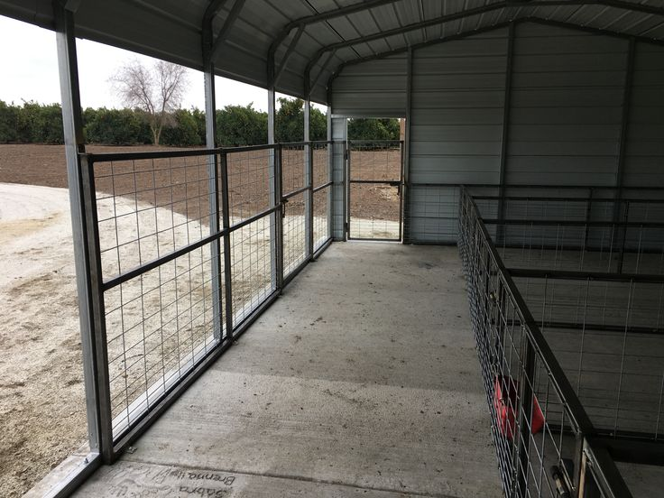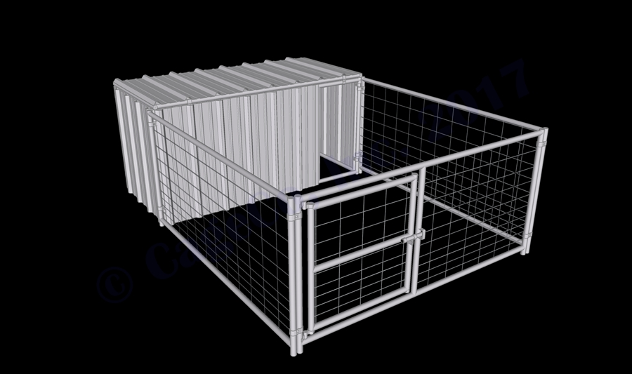
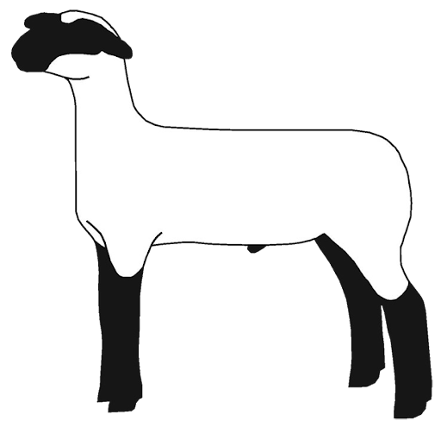
The Average Goat or Lamb Showman
- Cost of Animal: $900
- Feed Cost/week: $20
- Weeks on feed: 24
- Supplies/year: $150
- Extras- Entry fees, vet bills, etc: $200
  - Total Investment Cost/year: $1,730
Hours Spent on Project: 168
Experience….. PRICELESS!!
**The student is responsible for all costs and fees associated with any project. The Advisors are only there to help when help is needed. The student keeps all winnings and profit generated by the animal project!
Options: Wether Lambs/Goats (6-7 MONTH PROJECT)
When do they begin? You must have your lambs/goats by Nov 15. Most students buy lambs/goats before school starts!!
Extras (the student will need to get possibly:
Shavings -$7/bag (pens will need to be cleaned at least every 5 days)
If they get sick: Vet fees vary
Travel: Parents are responsible for taking students to shows; Advisors will haul animals if arranged.
(**There is no way to predict everything that could happen)
Products: Keeping an animal WELL groomed is KEY! So, hair care products are essential and could run $20/can…many cans are needed.
Supplements: Deworming your animal monthly is non-negotiable. You must purchase the proper medication for this. Also, If we travel to prospect shows, you will need to purchase the proper vitamins for your animals.
TIME: Time is the most important factor when showing lamb and goat projects! They MUST be fed at least 2 times a day, must be washed, water buckets must be CLEAN at all times, animals walked, weighed, etc. All of this has to happen everyday for those who want to succeed!
PROPER PEN: a lamb/goat needs to have a 6’x10’ area and needs to be able to get out of that pen to be walked. Ideally (not required, but highly recommended)- a pen would be fully concreted OR have a part of the pen that has concrete (it helps the structure and growth of the animal). The pen needs to have a 3.5 sided house so that the lamb/goat can stay warm and out of the elements.
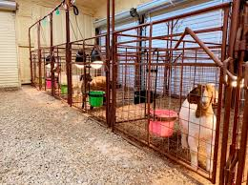

The Average Cattle Showman
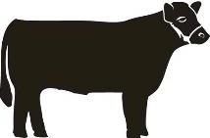
- Cost of Animal: $2,500 (this is a very low estimate at times)
- Feed Cost/week: $40
- Weeks on feed: 48
- Supplies/year: $250-$1000
- Extras- Entry fees, vet bills, etc: $300
  - Total Investment Cost/year: $4,970
Hours Spent on Project: 672
Experience….. PRICELESS!!

**The student is responsible for all costs and fees associated with any project. The Advisors are only there to help when help is needed. The student keeps all winnings and profit generated by the animal project!

Options: Steers or Heifers (1-2 YEAR PROJECTS)

When do they begin?
Registered heifer projects can be purchased when the heifer is 6mo old and shown until they are 24 mo. old. **Must be in the student’s name by Oct 31st!
Steer projects for Majors must be purchased by June 1st and Validated, for County they must be purchased by Sept 15 (about).

Extras/Supplies (the student will need to possibly get):
Hoof Trimming: every 6 weeks ($30-$40)
Health Papers: every time you go to a show ($5)
Breeding: (heifers only) up to $100
Travel: Parents are responsible for taking students to shows; Advisors will haul animals if arranged.
Hotels: Parents are responsible for hotel rooms for students at shows
(**There is no way to predict everything that could happen)
Products: Keeping an animal WELL groomed is KEY! So, hair care products are essential and could run $20/can…many cans are needed.
Supplements: Hay, Fast Fat, B12, etc. (all of these will be explained as needed)

TIME: Time is the most important factor when doing a cattle project! They MUST be fed at least 2 times a day, must be washed, walked, halter broke, etc. All of this happens everyday for those who want to succeed!

PROPER PEN: 10’x20’ fenced area with “shed” that protects the animal from elements. An area to wash the animal and the student needs to be able to catch the animal to work with it daily. Ideally where the animal drinks would be a concrete area to prevent mud and health issues. The pen needs to be dirt (not mud) and kept clean with shavings, etc.
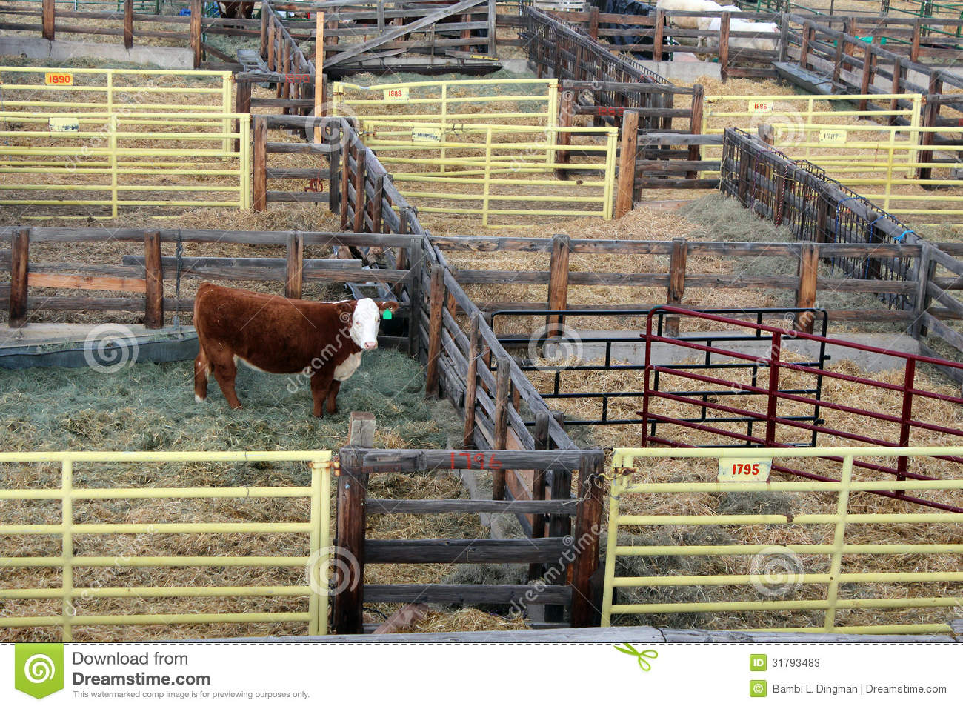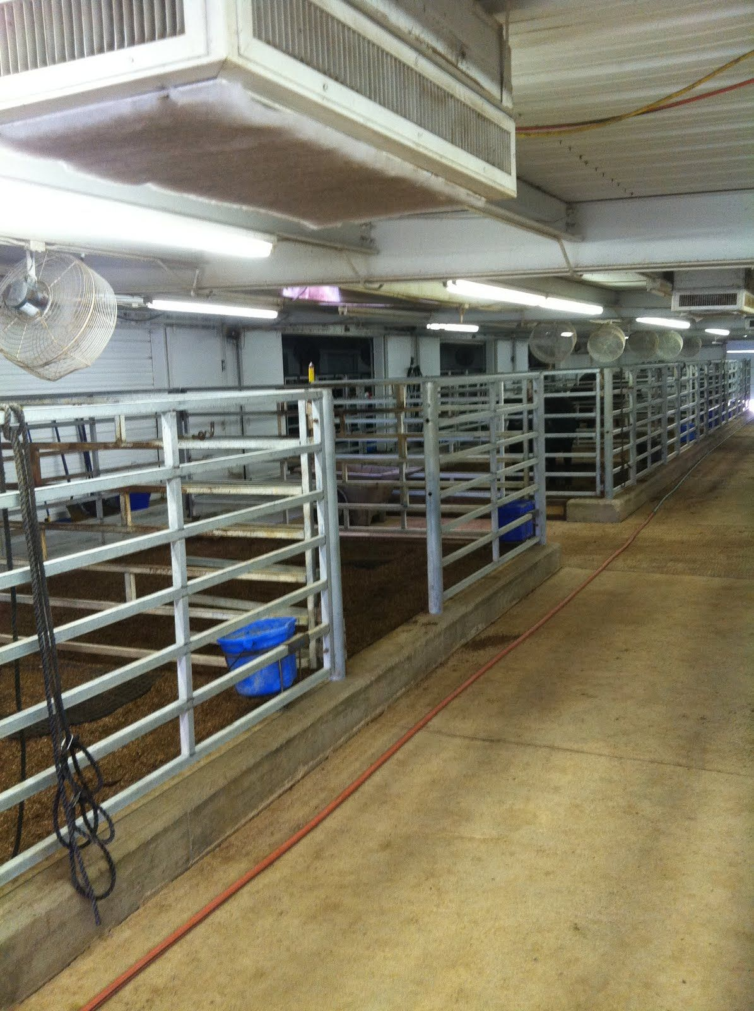

The Average Rabbit Showman
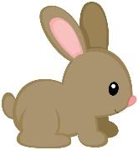
- Cost of Animal: $300
- Feed Cost total: $40
- Weeks on feed: 4
- Supplies/year: $150
- Extras- Entry fees, vet bills, etc: $40
  - Total Investment Cost/year: $530
Hours Spent on Project: 56
Experience….. PRICELESS!!

**The student is responsible for all costs and fees associated with any project. The Advisors are only there to help when help is needed. The student keeps all winnings and profit generated by the animal project!

Options: Rabbits are purchased in January-February (deposit is made to breeders of show rabbits in the fall) and only kept for 4-weeks. You can find your own breeder or Advisors can help. They MUST be the correct age! Talk to an Advisor if you have questions.

When do they begin?
At the end of January-beginning of February, you will get your rabbits.

Deposit of $100 is due on October 15th for Panola County (varies for other shows)

Extras (the student will need to get possibly:
Pens/Cages: These need to be HANGING cages and they need to be away from dogs/animals that can get the rabbit through the bottom of the cage. They need to be out of the elements.
Feeders, Water Bottles: ~$10
A kitchen scale is REQUIRED- make sure it weighs “to the ounce”
Travel: Advisors will only travel with rabbits to the County Show
Products: Keeping an animal fed is the main key. An antibiotic that you can add to the water is a good idea.

TIME: They MUST be fed at least 2 times a day. Rabbits need to be tame when they show, so working with their hair and getting them use to you is a daily requirement to be successful

PROPER PEN: rabbits need handing cages- away from dogs and predators. They need to EACH have a separate pen, water bottle and feeder. They need to be out of the elements of wind and rain but are fine with cold weather.

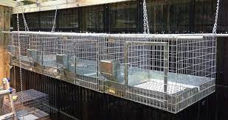

The Average Chicken Showman
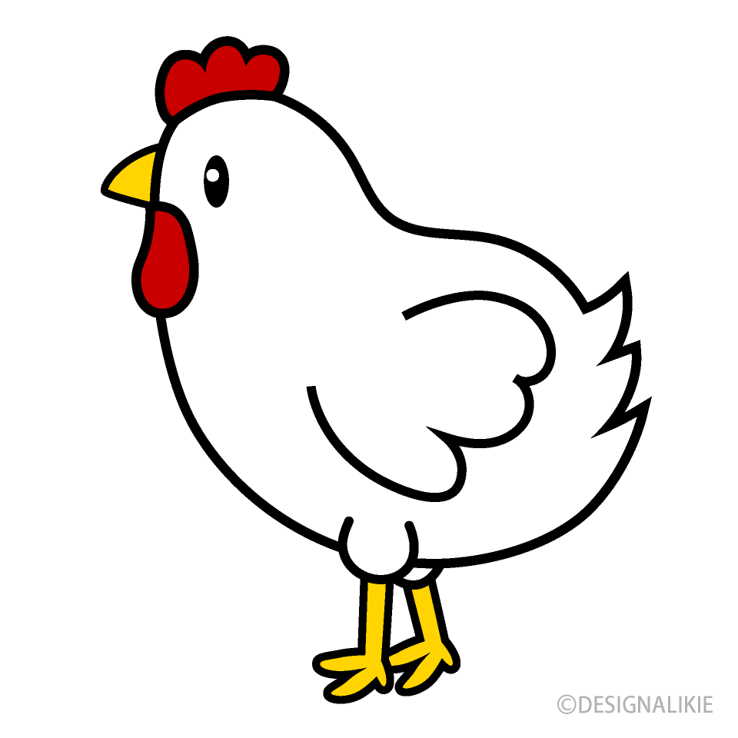
- Cost of Animal (50): ~$100
- Feed Cost: $500
- Weeks on feed: 6
- Supplies/year: $250
- Extras- Entry fees, vet bills, etc: $50
_____________________________________________________________________
- Total Investment Cost/year: $900 (not including the pen set up)
Hours Spent on Project: 100
Experience…... PRICELESS!!
**The student is responsible for all costs and fees associated with any project. The Advisors are only there to help when help is needed. The student keeps all winnings and profit generated by the animal project!

Options: Chickens must be ordered through the Ag Teachers (the time frame varies depending on the show) all birds come from the same place (a hatchery). You get a box of 25-50-75 birds and show 3 of them. (6 WEEK PROJECT)

When do they begin? In the middle of January you will get your birds for Panola County.Varies depending on the show.

Cost: Varies per show..

Extras (the student will need to get possibly):
Shavings -$7/bag (pens will need to be cleaned at least once a week)
Travel: Advisors will only travel with chickens to the County Show
Products: muscle or fat products are needed
Fans and Heat lamps are required to maintain proper temperatures at all times.

TIME: They MUST be fed at least 4 times a day. Chickens are a NOT low-maintenance project. The goal is to feed them and water them constantly and often and make sure they are cold when they need to be cold and warm when they need to be warm. THIS TAKES FOLLOWING A STRICT PLAN. This takes MANY feeders and MANY waterers AND a strict temperature plan (decreasing as the weeks progress and the birds grow). Cleaning shavings happens daily, freshening feed and water happens daily. This is a project that is short but VERY hands-on!

PROPER PEN: ideally a bird will have 2 square feet of space when it is full grown- space is dependent on the number of birds you get. A building that is heated and cooled and climate controlled is required for success.
